Teacher’s Guide:
MINERvA Billiard Ball Reaction
Intermediate Level

Classroom Objectives:
- Each student or student group uses Arachne to compile data from their own 10 billiard ball type events.
- Conservation rules are applied to the compiled data to make determinations about neutrino and neutron momenta for each event.
- The results from each student set are merged together to make one “super” set of class data.
- The class data set is used to lead students through a discussion about the range of possibilities in these billiard ball reactions. Specifically, there is a range of neutrino momenta that cause the billiard ball type of reaction and there is a range of neutron momenta that reveals something about the motion of a neutron within the nucleus of a carbon atom (the MINERυA experiment uses carbon atoms as the neutron target/source).

Activity Overview:
This activity asks your students to use conservation of momentum to investigate a two particle collision between a fast moving neutrino (υ_{μ-}) and a “stationary” neutron (n⁰). Stationary is in quotes because neutrons actually vibrate and zip around the confines of an atom’s nucleus at surprisingly high speeds. A proton and a muon are the particles produced in this collision. The particle collision is represented below:

υ_{μ-} + n⁰→ p⁺ + μ⁻

MINERυA provides information about each product particles momentum and energy. Students will focus on the product momenta data to:
- determine the z-axis momentum of the incoming neutrino and,
- to find the neutron’s x-axis and y-axis velocity within the nucleus at the moment of collision.

This intermediate activity adds a layer of complexity to data analysis because separate student results must be merged together and then presented to the class. Merging can be done by hand with students in the classroom or by the teacher merging student Excel files.

Prerequisite Knowledge:
- The teacher (and students) must be familiar with Arachne. (see Teacher’s Guide Basic Level)
- The teacher (and students) must know the conservation of momentum principles that apply to this billiard ball type reaction. (see Bug & Garbage Truck Collision ppt)
- The teacher must know how to construct histograms from large data sets. (see Teacher background Information for Introducing Histograms to Students)

Incorporating Excel:
This activity gives you the option to let your students use Excel to organize, manipulate and display data. The Arachne site is compatible with Excel. Instead of students writing down muon and proton data on a worksheet and then adding the data and graphing it by hand, the computer quickly transfers event data from Arachne to Excel with the click of a few buttons. Then, the students can use Excel formulas to add the data.
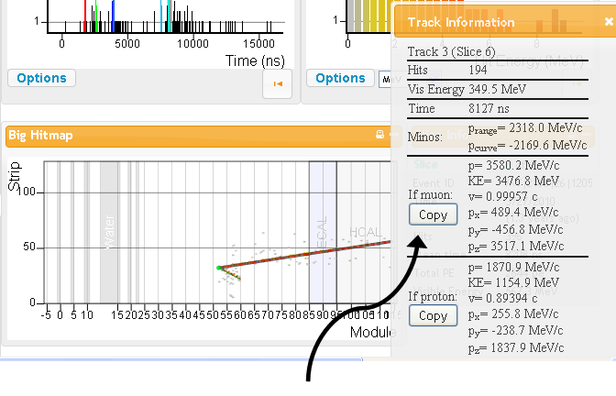
When students are comfortable determining if the track information describes the muon or the proton, the next step is to COPY the information into Excel. This is done in three steps
- clicking on the copy button under Track Information in Arachne (see above),
- opening an Excel window, and
- use the PASTE command to put the information into the proper place on an Excel spreadsheet.

An Excel template is provided on the website under the same menu heading as this document. This template is useful because it gives a uniform data collection sheet for all students. When students open this template they will see a screen that looks like the screen shot below.

Before a student copies data from Arachne into Excel, the entry file number that appears on the left hand side of the Arachne screen should be typed into Excel’s cell A3 under the heading “event”.
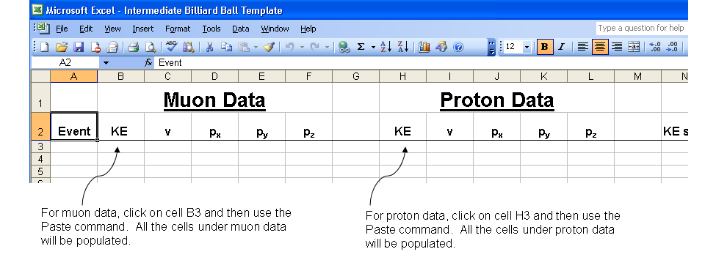
Students should copy data from their first Arachne entry file into row 3. Specifically, muon data is pasted into cells B3 through F3. Proton data is pasted into cells H3 through L3.
The paste command works if students click on cell B3 for muon data and cell H3 for proton data. For the second Arachne entry file, data is pasted into cells B4 and H4. Data from the third Arachne entry file is pasted into cells B5 and H5, etc. Muon and proton data from the 10th Arachne entry file appear in row 12.

- At this point, it is wise to save a file using a naming system that the teacher has worked out with students. The naming system will be important when it comes time for the teacher to merge the files into one big “super” Excel spreadsheet.

- After students copy data from 10 entries into Excel, Excel will be used to add the energies and momenta. The space on the template to do this is under columns N through Q. Students must type commands so that Excel sums muon and proton kinetic energies (KE) from a single entry. the momentum, axis by axis. Students must click on cell N3 and type the following command into this cell: =B3+H3 and then press enter.

As the students type, the command will appear in Excel’s cell N3 and look like the snapshot below.
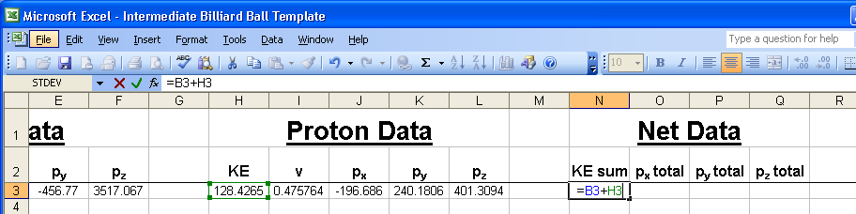
Cell N3 is now populated by the sum of the KE’s that appear in cells B3 and H3
-------------------------------------------------------------------------------------------------------------------------------
- Next, the student will use a similar formula to sum the x-axis momenta. In cell O3, students type:
=D3+J3 and press enter.
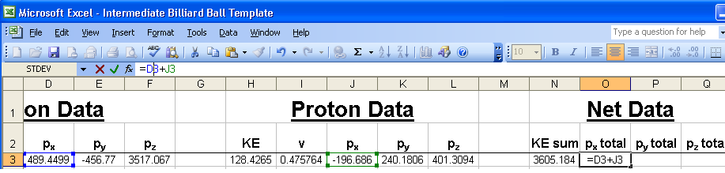
Cell O3 will be populated with the sum of cell D3 and J3.
-------------------------------------------------------------------------------------------------------------------------------
The command to sum the y-axis momenta in cell P3 is: =E3+K3
The command to sum the z-axis momenta in cell Q3 is: =F3+L3

- Now, the students will use the convenience of Excel to “drag” down a formula so that energies and momenta are summed for each entry.
  - The student must highlight cells N3 through cells Q3, and
  - move the mouse so that the cursor appears as a ‘plus sign’ at the lower right corner of cell Q3,
  - then, hold the mouse button, drag down to cell Q12, and release the mouse button. Each cell from N3 to Q3 should be populated with the energy or momentum sum for that row’s Arachne entry.

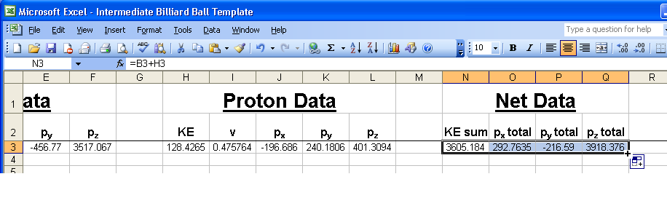
Merging Data:
After students compete their Excel template.

MINERvA - Arachne Collection Sheet
Event |  | Muon  momentum |  |  | Proton momentum |  |  | Sum of momentum
Entry # | slice | p_{x} | p_{y} | p_{z} | p_{x} | p_{y} | p_{z} | p_{x} | p_{y} | p_{z}

ANALYSIS:

- Determine the smallest and greatest sum in momentum along the z-axis.

- How many of the sum of p_{x} and sum of p_{y} are positive and how many are negative?

- Why are the z-axis momenta always so much larger than either the x or y-axis momenta?

- Before the collision what was assumed about the momentum of the neutron along the x & y-axis?

b. Looking at the sum in momentum along the x & y-axis what must one now conclude about the
initial momentum of the neutron. Justify.

